Thermal Anomaly Detection in Electrical Systems

Convolutional Autoencoder: We mainly need pictures of normal instalations without failures, and a few ones with failures to test it. In electrical maintenance, failure data is scarce, while normal operational data is abundant. This model allows us to detect anomalies without needing a pre-labeled library of every possible electrical fault.
How it works?
1)The Convolutional layers identify the physical structure of the electrical components.
2) The model learns the statistical distribution of pixel intensities (T) associated with those specific shapes.
3) The model predicts what the thermal intensity should be for a given geometry based on its training on healthy data.
4)Computes the error between the prediction and the real image.
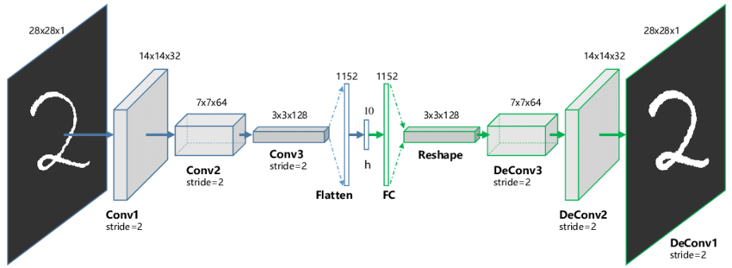
https://www.sciencedirect.com/topics/computer-science/convolutional-auto-encoder

Step-by-Step Implementation
Phase 1: Data Acquisition
Training:Capture 200+ images of the electrical panel under normal operating conditions.
Validation : Separate a small group of images containing anomalies (hotspots) to test the model's accuracy.
Phase 2: Image Normalization
Standarization: We convert images to grayscale, standardize their size, and scale the values.
Phyton: Library OpenCV and import cv2 as a code
Phase 3: Filtering
Objective: Isolate electrical components from the background.
Phyton: Library Numpy,, values below certain value become black.
Phase 4: Model Training
Convolutional Autoencoder: The model is trained only on normal images. It learns to reconstruct the "latent representation" of a safe installation.
Phyton: We use TensorFlow/Keras and we optimze it with MSE,
Phase 5: Detection Logic.
Detection: We calculate the difference between the real image and the AI's version.
Phyton: If the error is higher than our limit it's an anomaly.

